Ragdoll Royale _______________________________

Submitted by

Muhammad Abdullah (Fa22-BSCS-035-D)

Taha Siddique (Fa22-BSCS-148-D)

Session 2022-2026

Supervised by

Mr. Sheikh Zubair



Department of Computer Science

Lahore Garrison University

Lahore

A RTS PHYSICS BASED GAME

A project submitted to the

Department of Computer Science

In

Partial Fulfillment of the Requirements for the

Bachelor's in Computer Science

By

Muhammad Abdullah (Fa22-BSCS-035-D)

Taha Siddique (Fa22-BSCS-148-D)

Internal Supervisor

Teacher Name _______________________

Designation

Department of Computer Science

External Examiner _______________________

Chairperson

Dr. Muhammad Kashif Siddhu _______________________

Assistant Professor

Department of Computer Science

COPYRIGHTS
This is to certify that the project titled “Ragdoll Royale” is the genuine work carried out by Muhammad Abdullah (Fa22-Bscs-035-D) and Taha Siddique (Fa22-Bscs-148-D), students of BSCS of Computer Science Department, Lahore Garrison University, Lahore during the academic year 2022-26, in partial fulfilment of the requirements for the award of the degree of Bachelor of Computer Science and that the project has not formed the basis for the award previously of any other degree, diploma, fellowship or any other similar title.

_______________________
MUHAMMAD ABFULLAH

_______________________
TAHA SIDDIQUE

DECLARATION
This is to declare that the project entitled “Ragdoll Royale” is an original work done by undersigned, in partial fulfilment of the requirements for the degree “Bachelor of Science in Computer Science” at Computer Science Department, Lahore Garrison University, Lahore. All the analysis, design and system development have been accomplished by the undersigned. Moreover, this project has not been submitted to any other college or university.

Group Members
Muhammad Abdullah _______________________
Taha Siddique _______________________

Supervisor

Mr. Sheikh Zubair _______________________

Date: 21st, April, 2026

DEDICATION
Our project is to ourselves, first and foremost, we are dedicating this project to our dedication, teamwork, and determination to make an idea a reality. We also give it to couple of friends that we have met on the way, and our support system whose support, encouragement and moments of time together made this journey really worthwhile. Most importantly, we dedicate this project to those who miss listening to the world better- to experience all words, all laughs, and all moments with their loved ones. Hopefully, this attempt will make hearts become closer and each sound matter.

ACKNOWLEDGEMENTS
To begin with, we want to acknowledge our utmost gratitude to Allah Almighty that gave us strength, knowledge, and power to complete this project successfully. We would like to acknowledge with high esteem our Head of Department, Dr. Abdul Sattar, who provided guidance and support on this journey. Our heartfelt gratitude to our supervisor, Mr. Sheikh Zubair is also due to her helpful advice, motivation, and constant support in all the phases of this project. We owe our parents a great debt of gratitude due to their all-time support, motivation, and faith in us. Our strength has been their encouragement. We would also like to thank our teachers and mentors, especially Ms. Aleen Ijaz Chaudhry, for their guidance, inspiration, and knowledge, which greatly contributed to the completion of this work. Finally, we would also like to thank all those who either directly or indirectly helped us make this project successful.

List of Abbreviations
- AI: Artificial Intelligence
- API: Application Programming Interface
- BSCS: Bachelor of Science in Computer Science
- CGE: Computer-Generated Environment
- FPS: Frames Per Second
- FYP: Final Year Project
- GPU: Graphics Processing Unit
- LGU: Lahore Garrison University
- OBE: Outcome-Based Education
- RAM: Random Access Memory
- SDK: Software Development Kit
- SRS: Software Requirement Specification
- UI: User Interface

Table of Contents

Chapter 1 1
INTRODUCTION 1
1.1 The Project Background and Its Overview 1
1.2 Industry Problem and unmet needs 2
1.3 Project Aims and Proposed Solution 3
1.4 Project Scope 3
1.5 Report Organization 4
Chapter 2 5
LITERATURE REVIEW 5
2.1 Domain and Historical Context 5
2.2 Market Gap Analysis and User Unmet Needs 5
2.3 Comparison of Proposed Methodology with Existing Solutions. 6
Chapter 3 7
PROBLEM DEFINITION 7
3.1 Statement of the Problem. 7
3.2 Technical, Algorithms, and Design Challenges 7
Chapter 4 9
SOFTWARE REQUIREMENT SPECIFICATION 9
4.1 Introduction 9
4.2 Overall Description 11
4.3 External Interface Requirements 13
4.4 System Features 14
4.5 Other Nonfunctional Requirements 16
4.6 Detailed Use Case Narratives 17
Chapter 5 18
METHODOLOGY 18
5.1 Introduction to the Development Lifecycle 18
5.2 Software Development Methodology 18
5.3 Algorithmics and Techniques 19
Chapter 6 20
DETAILED DESIGN AND ARCHITECTURE 20
6.1 System Architecture Overview 20
6.1.1 Architecture Design Approach 20
6.1.2 High-Level Subsystem Architecture 21
6.2 Detailed System Design and Component Specifications 22
6.2.1 Classification, Definition, and Responsibilities 22
6.2.2 Constraints, Composition, and Interfaces 22
6.3 Mathematical Physics Modeling and Rigid Body Dynamics 32
Chapter 7 34
IMPLEMENTATION AND TESTING 34
7.4 Screen-by-Screen Interface Implementation Narrative 36
Chapter 8 38
RESULTS AND DISCUSSION 38
8.1 Comprehensive Evaluation of the Solution 38
8.2 Operational Results and Strategic Gameplay Mechanics 38
8.3 Validation of Safety, Security, and Business Rules 39
8.4 Discussion of Technical Achievements 39
CONCLUSION AND FUTURE WORK 40
9.1 Summary of Project Achievements and Conclusion 40
9.2 Recommendations and Future Work 40

ABSTRACT

The modern mobile game market has had a massive growth rate in the past ten years, shifting the traditional, arcade-like games into extremely complex simulations that can rival the conventional console games. Yet, this booming growth has also come with a lot of user experience issues, chiefly fueled by predatory, aggressive monetization policies, in-your-face third-party ads, and an apparent lack of content that is family-friendly and strategically deep. The proposed Final Year Project (FYP) features a strategy game titled Ragdoll Royale, a Unity based, physics-oriented, mobile game carefully designed to fill these gaping gaps in the industry. The main issue that this project aims to address is the overcrowding of the mobile market with strategy games, which impairs the immersion of the player with a high level of ads and adheres to a model of combat resolution that is not based on active and dynamic simulation processes but rather on a single, mathematically predictable result.
Ragdoll Royale attempts to overcome these dominant problems by introducing a special, split gameplay cycle. During the first part, the players have to position their assigned ragdoll units in a strategic manner. A very severe level-based deployment cap restricts this deployment, requiring players to maximize spatial placement and tactical positioning instead of overwhelming the enemy with numbers. After the deployment is complete, the game turns into an autonomous battle simulation.
Moreover, Ragdoll Royale adopts a focused, offline multiplayer layout. This includes same-device pass-and-play functionality, explicitly avoiding the caustic anonymous matchmaking and network latency found in online games. This project proves that complicated physics calculations can be best scaled to mobile hardware through intensive testing of its spatial hashing algorithms to deploy troops and pathfinding of autonomous agents.

Chapter 1

INTRODUCTION

1.1 The Project Background and Its Overview
The mobile computing and interactive entertainment landscape has changed at an alarming rate. Developers no longer have to use the two-dimensional sprites and primitive logic of the past when the development of multi-core mobile processors and improved built in Graphics Processing Unit (GPU) has come into being. In this new field, strategy games and physics-based simulations have established huge, devoted followings. Players are increasingly demanding emergent gameplay - situations in which the result is not programmed, but rather emerges out of the inherent complexity of the interaction between discrete mechanics.
Nonetheless, integrating strategic resource management and unforeseeable, physics-based warfare is still a challenging technical problem, especially when it comes to attacking the various ecosystem of mobile hardware. This project conceptualizes, designs and executes “Ragdoll Royale”, a complete, mobile-based physics-based strategy game that is built on Android (version 9.0 and above) and iOS (version 13 and above) platforms. Developed with the industry-standard Unity game engine, Ragdoll Royale challenges the player to take the position of a battlefield commander in a tactical game.
The gameplay cycle is broken down into two cognitive stages with the purpose of division. The initial is the phase of tactical deployment, and it is about the assessment of a computer-generated battlefield, the control of a strictly fixed deployment budget and the use of intuitive touch controls (drag-and-drop) to deploy specialized ragdoll soldiers into the specific legal area. The game places the entire control in the hands of an autonomous AI system, as opposed to requiring high-actions-per-minute (APM) inputs or quick reaction to the next round of combat. Players are no longer active participants but rather analytical spectators observing their strategic vision be played out with physics-simulated ragdoll units fighting in simulated and model-independent combat until a clear win or loss condition is reached.

1.2 Industry Problem and unmet needs
Although the mobile gaming industry is incredibly profitable in terms of financial benefit, there are still numerous unmet demands and endemic, structural issues that still affect the satisfaction of players and their psychological health. The three fundamental challenges in this genre of mobile strategy are identified in this project:
- Predatory Monetization and Intrusive Advertisements: Third-party advertisement networks have become central to the business of modern mobile games, as a way of making money. This makes the gameplay often interrupted by un-skippable video ads, banner ads, and pop-ups. This does not just destroy the immersion of the user, but these ad networks also tend to show content that is completely inappropriate, crass or deceptive to children, making the environment hostile to children.
- Lack of Family-Friendly Strategic Depth: The strategy genre is often flooded with titles that tend to go into hyper-realism violence, gore, or over-convoluted user interfaces. A clear gap in the market is the casual family-friendly titles that can be enjoyed by a non-expert mobile user and amateurs and at the same time require a valid cognitive planning and spatial reasoning.
- Predictable and Static Combat Systems: Most existing mobile strategy games are based on spreadsheet-based combat resolution. In such systems, a unit of a larger numeric value will always beat a unit of a smaller numeric value, thus, simplifying the game to a mere mathematical contest. This totally eliminates the aspect of emergent gameplay, randomness, and visual amusement that dynamic physics engines could offer.
Ragdoll Royale is designed to address these particular problems. It ensures a safe, ad-free environment, which is also kid friendly by an in-game purchase system entirely dependent on optional, transparent in-game purchases as a replacement of ad-driving revenue generation. Moreover, because of its underlying use of a physics engine, it is guaranteed that no two battles will ever be played in precisely the same way, except in theory, which is infinitely reproducible, as a result of emergent, model-independent battle situations.

1.3 Project Aims and Proposed Solution
The main objective of this Final Year Project (FYP) is to complete the entire software development lifecycle, including requirement gathering, deployment and develop a fully functional mobile strategy game that takes advantage of complex mobile physics calculations without compromising on performance. Ragdoll Royale is a proposed solution which is characterized by the following pillars of the solution:
- Thematic and Functional Diversity: In order to offer a variety of tactical choices, different units of four different themes can be ordered around. Military faction consists of normal Infantry (punchers). The Modern side employs Plasma Cannon Dueler. The Mythic theme brings in Sword Nanobot.
- Limited Units Per Level: Only a small number of units can be used at any level. Real-time algorithms dynamically adjust the available unit slots in the drag and drop stage and instantly limit placements when the player attempts to exceed the number of units they can deploy, or attempt to place units outside of the geometrically defined legal area.
- Friendlier and Safer Topologies: Ragdoll Royale is hugely controlled and plays local play to encourage community play and social interaction without having to deal with the toxicity that's often seen with global online platforms. Fully offline pass and play on one machine to support strategic face-to-face game.

1.4 Project Scope
Ragdoll Royale is strictly defined to be deployed successfully and highly polished to run on middle-end mobile hardware architectures (with at least 4GB RAM and a simple integrated graphics core). The entire scope of the product includes:
- The complete design and implementation of a high-quality, very responsive touch-based User Interface (UI) that precisely responds to tap, drag, and pinch gestures to deploy troops accurately.
- The architecture and code of autonomous battle agents based on Finite State Machines (FSMs) capable of effectively identifying enemies and pathfinding and attacking with complex ragdoll physics in a computer-generated environment (CGE).
- The combination of streamlined local device storage architecture to store the progress of solo campaigns and user preferences to use them and Application Programming Interfaces (APIs) necessary to run the room-hosting multiplayer functionality.*
- An extreme, no-compromise belief in software safety and non-functional requirement, where there is no harmful content, no flashing or otherwise disorienting graphics, and a highly efficient rendering pipeline capable of supporting 20-plus physics-enabled units on the battlefield at all times and with a steady framerate of at least 60 FPS.

1.5 Report Organization
This paper is well-organized to give a comprehensive, scholarly summary of the software development cycle, architectural choices and performance metrics of Ragdoll Royale.
- Chapter 1 is a complete introduction of the project with the core background, goals and scope of the project.
- Chapter 2 explores the Literature Review, covering the historical background of mobile strategy games, physics engines development, and an examination of how it is currently being monetized in the market.
- Chapter 3 officially states the Problem Statement, which describes the particular technical, algorithmic, and design restrictions of developing a mobile game.
- Chapter 4 describes the Software Requirement Specification (SRS), which will give a detailed description of all the functional and non-functional requirements.
- In Chapter 5, the Methodology is discussed, including the agile development models, particular programming tools and mathematical algorithms used.
- Chapter 6 goes into the Detailed Design and Architecture and traces the high-level architecture of the system, its object-oriented hierarchies of classes and its data flow diagrams.
- In Chapter 7, we discuss Implementation and Testing, which content is how the core functionalities were converted into code, and the rigorous testing plans undertaken.
- Chapter 8 is the Results and Discussion with a critical analysis of the performance, accuracy, and adherence of the game to the initial specifications.
- The final chapter of the report (9) is the holistic summary of the project success and further directions of future work and further software development.

Chapter 2

LITERATURE REVIEW

2.1 Domain and Historical Context
Combining sophisticated physics simulations into the ecosystem of mobile game development and consumption is a major paradigm shift in interactive entertainment development and consumption. This chapter gives an in-depth summary of the historical background, the current practices, and the new technologies that put in perspective the formation of Ragdoll Royale. In the past, processing power and memory bandwidth were grossly constrained by early mobile games. As a result, they used nearly pre-written, hard-coded animations and simple, flat 2D hit-boxes to decide on interactions.
Nonetheless, the spread of highly developed mobile System-on-Chips (SoCs) has made access to incredible amounts of computational power democratized. This computer revolution has enabled the portability of advanced physics engines, including the PhysX by Nvidia (heavy support in the Unity Engine) and Havok, to mobile platforms. Such engines enable the developers to abandon scripted animation and adopt dynamic ragdoll physics. In this current paradigm character models are considered as a system of rigid bodies connected by constraints and joints, and are capable of responding to forces in the environment, collisions, and gravity in a very realistic, computationally obtained fashion. Physics-based battle simulators have thereby become a sub-genre, which is quite popular with the strategic thinkers and those who enjoy a casual game, and where the emergent behavior of autonomous agents is found to be entertaining.

2.2 Market Gap Analysis and User Unmet Needs
Critical examination of the existing mobile application market will disclose that there is a huge, multifaceted unmet need that this Final Year Project provides. Although the marketplaces such as the Google Play Store and Apple App Store are significantly flooded with strategy and simulation games, most of them are severely flawed in design and ethics, thus bringing down the user experience.
First and foremost, the current mobile ecosystem is supplanted by highly monetized Freemium models full of intrusive and aggressive third-party ad networks. Such SDKs often serve full-screen, non-skipping video ads and fake interactive pop-ups. On top of interrupting the gameplay, such networks often recycle content that is algorithmically focused but contextually unsuitable, occasionally subjecting younger audiences to crude, terrifying or very adult content. This puts a very unfavorable atmosphere on parents who want to have family friendly entertainment.
Moreover, gameplay-wise, most strategy games that are currently available demand fast and unremitting user interactions, also known as micro-management, at the point of the actual battle. This greatly discourages the casual players, younger players or those with accessibility requirements. The absence of games that are easy to access and that are aimed at non-expert mobile users and amateurs that concentrate on the macro-level strategic planning and the observation-based gameplay is evident. Ragdoll Royale fills this very gap by dividing the tasks of strategy and analytical deployment phase and the execution phase, leaving the player to watch autonomous AI conflict solved through physics without the strains of real-time manual control.

2.3 Comparison of Proposed Methodology with Existing Solutions.
In comparison to the current solutions available in the market, the Ragdoll Royale stands out with its strict compliance with ethical choice of software design and high-performance architectural decisions. In order to ensure a safe and family-friendly experience, the game completely removes the use of third-party advertising APIs. Rather, it will be based on a sustainable transparent monetization model that only relies on optional in-game purchases.
Making sure that the computation of the complex joint constraints of dozens of ragdolls remains stable is infamously challenging on mobile hardware, technologically. Lots of current games solve this by radically decreasing visual fidelity or artificially capping the amount of units to single digits. The approach of Ragdoll Royale neutralizes this by capitalizing on the Unity game engine which is highly optimized and by its native, multi-threaded Physics engine. With a careful use of collision matrices and the spatial partitioning algorithms when it comes to the proximity detection of the AI, the game is made in such a way that the mobile CPU is not limited by O(N 2) distance computation. Moreover, with its strong offline solo play, same-device pass-and-play multiplayer, and a secure online multiplayer, using hosted rooms (explicitly avoiding the toxicity created by random matchmaking), the proposed solution offers a vastly more controlled, highly strategic, and technically impressive alternative to existing market offerings.

Chapter 3

PROBLEM DEFINITION

3.1 Statement of the Problem.
The main issue which this Final Year Project deals with is the ubiquitous absence of safe, physics-based, and purely tactical simulation games in the mobile market that manage to strike a proper balance between the in-depth strategy and the rigidly ethical design and hardware optimization. The modern genre of mobile strategy is often motivated to commit the sin of using a pay-to-win dynamic and monetization loops based on aggressive advertisements. Such practices drastically lower the quality of the software overall, interrupt user immersion and most importantly, endanger the user safety by possibly showing out of age content to children. Moreover, games that do seek to use physics-based combat are usually severely slow, and cause intolerable frame-rate loss, battery use, and thermal throttling on middle-end mobile platforms.

3.2 Technical, Algorithms, and Design Challenges
Developing a workable solution to this issue places an array of complicated technical and algorithmic constraints that need to be surmounted through the software architecture stage.
- Computational Complexity of Physics Simulations: On a purely technical basis, the problem of computing real-time, model-independent fights with ragdoll physics, and realistic physics, is a resource-intensive one. Each ragdoll unit can have 10-15 individual rigid bodies and complex joint constraints. When there are 20 or more units on the battlefield, hundreds of collision checks and intersecting geometry are to be computed and solved each frame by the physics engine. The main difficulty is creating an ideal mobile physics computation architecture - based on such techniques as the layer-based collision culling and simplified colliders - that ensures at least 60 FPS on the hardware that is capable of running it, without making the simulation look any less realistic.
- Autonomous AI and Pathfinding: It is a major challenge to create an AI system that seems intelligent and yet has a light computational footprint. The units should be capable of detecting enemies within their range dynamically. Assuming that each of the 20 units compares its distance with all the other units in one frame, the computational complexity grows slowly. The problem here is to apply effective spatial data structures or ray casting algorithm where autonomous battle agents assess their environment, target selection, and pathfinding through the computer generated environment, as efficiently as possible.
- UI and Spatial Validation Constraint: To have an effective drag-and-drop system, the mapping between 2D screen space (touch input) and 3D world space must be very accurate. Whether the drop location selected by a user is within the legal space or intersects legal restricted areas must be immediately verified by the system, and exactly raycasting algorithms are needed to make sure that the requirement of REQ-5: Do not allow placement outside of legal zones is met without introducing latency to the UI.
- Networking and Synchronization Constraints: Developing a seamless multiplayer experience has a unique set of challenges, especially when following the constraint of not using external paid SDKs. The game should support pass-and-play logic on the same device, which will need to have secure state management to conceal deployment information between rounds, and online hosted rooms. To synchronize the exact result of a highly volatile physics simulation running on two devices over a mobile network, it is necessary to transmit deterministic random seeds and coordinates of unit locations to make sure that both clients compute the exact result of a battle on their own.

Chapter 4

SOFTWARE REQUIREMENT SPECIFICATION

4.1 Introduction

4.1.1 Purpose of the Document
The basic idea behind this Software Requirement Specification (SRS) is to provide a detailed, clear and very detailed break down of the functional non-functional requirements that determine the creation of the ragdoll Royale. As the ultimate guide to the software architecture phase, the document sets the specifications of a Unity-based mobile strategy game. The fundamental gameplay cycle, recorded in this paper, involves the player placing the specialized ragdoll units onto a virtual battlefield in a strategic manner, and then witnessing the autonomous units solve the conflict situation through the use of powerful physics simulations. In addition, this SRS clearly defines the allowed topologies of players, making sure that they have the ability to play in a single player mode, implement a same-device pass-and-play multiplayer (limited solely to playing locally) or engage in online multiplayer games mediated by hosted rooms without the presence of random matchmaking systems. One of the most significant guidelines that have been set in this document is upholding a kid-friendly atmosphere; therefore, advertisements are reduced to the bare minimum and the overall monetization plan is implemented only with secure in-game buying.

4.1.2 Document Conventions
A number of strict document conventions have been adopted to make sure that every stakeholder can easily bypass and decode the complications of this specification. All the big headings and subheadings are numbered in a hierarchic way to create the definite flow of information. The functional requirements, which determine the interactive functionality of the system, are formally defined in the nomenclature of the "REQ-XX" nomenclature. Moreover, as a means of leading the development pipeline and helping to divide the engineering resources, all requirements are divided according to the level of priority: high, medium, and low. More importantly, all the requirements, which are described in this document, have been written in such a way that it is absolutely clear, and can be empirically tested.

4.1.3 Intended Audience and Reading Suggestions
The materials contained in this SRS are designed to suit a wide range of stakeholders in the software development lifecycle. The main target audience would include the Project Supervisor, the main Development Team, the Quality Assurance (QA) engineers and Testers, and the academic FYP Evaluators. The developers and testers are strongly encouraged to invest their main attention to Sections 3 and 4 of this specification because these sections include the actionable interface and functional requirements that can be used to code, and develop test-cases. On the other hand, the FYP evaluators and compliance officers ought to give a heavy eye to Section 5, which defines the strict quality attributes, performance benchmarks and compliance standards the end product should attain.

4.1.4 Product Scope
The scope of the product identifies the precise limit of the application of the Ragdoll Royale and that the application is a high-tech mobile strategy game. In the framework of this game, the player has to manoeuvre a ragdoll army under the tightest possible restriction of a dynamic, active budget algorithm. Once the deployment phase has ended, the scope will specify that players will become observers, observing autonomous AI combat that is solved dynamically through a ragdoll physics engine. The nature of the game encourages a variety of play-modes, enabling users to play alone in offline mode, or interact in the pass-and-play local multiplayer mode, or connect with the online multiplayer by privately hosted rooms worldwide. The level of strategic depth of the product is determined by the fact that the player can make rational decisions about the choice of specific troops, their accurate spatial positioning on the grid, and rational use of the available resources. One of the characteristics of the scope of the product is its determination to be very family-friendly. In a bid to make sure that the platform is not utilized to unintentionally expose users to vulgar or misleading content the scope strictly prohibits any integration of external ad networks, and states that the only acceptable method of revenue generation is localized in-game purchases. Finally, the scope includes a physics-based, strategy-based game that is both accessible, safe, and fun across demographics of all ages and technical abilities.

4.2 Overall Description

4.2.1 Product Perspective
In a more technical sense, Ragdoll Royale is a fully self-contained mobile app built in the environment of Unity game engine. It incorporates numerous, intricate subsystems in order to form a unified user experience. The product approach is based on the concept of the real time simulation of the realistic ragdoll warfare under strict Newtonian physics. This is smoothly combined with independent AI behavior algorithms that determine the way individual units interact with aggression. User interactionally, the view is very tactile with the focus being on the drag and drop mobility of troops in the digital battlefield. Lastly, the product view includes a powerful multiplayer system that can support localized pass-and-play, as well as distributed online room hosting.

4.2.2 Product Functions
The system is based on multiple interacting software modules that form the core functionality of the system. The game should also be able to offer the user a wide range of different types of troops, which are carefully sorted into different historical and fictional themes, such as military, Stone Age, science-fiction, and mythic/fantasy worlds. In order to create a strategic challenge, the system should have limited, fixed budgets that increase with the level being played. In the interaction stage, the software should ideally allow the players to easily choose and place troops physically in the 3D world, within the restrictions of their budget and given deployment areas. The engine will be tasked with continually validating and checking troop positioning to make sure that only valid areas are dropped on by units. After the fight has been started, the main task of the engine is to perform model-independent battles, and it solely uses autonomous AI fighting algorithms and does not use pre-generated, deterministic animations. At the end of the battle, the system needs to analyze the data in order to provide post-battle feedback and granular statistical analysis to the player. Moreover, the system features are the support of pass-and-play multiplayer using the same physical device, and the possibility of the players to play online with others using only secure and hosted rooms. The monetization being a fundamental fiscal activity, is managed by in-game purchases only, preventing any external ad calls.

4.2.3 Characteristics and classes of users.
The app will meet the needs of two different groups of users. Primary Users are considered to be players of the game. Typically, this segment consists of non-expert mobile customers and amateur gamers. Their interaction is highly focused on the general strategy of the gameplay which is inherently premised on observation and tactical planning instead of reflex-based and high-speed interactions. The Secondary Users include Instructors or Evaluators who will go through the system in an academic or developmental setup. The features of such users include critical analysis of the gameplay to evaluate the technical advancement, compliance with the requirements, or the analysis of the underlying algorithm of the strategy deployment.

4.2.4 Operating Environment
The constraints of the operating environment are strictly defined so as to achieve the highest market penetration and stable performance. The Android version 9.0 or higher and iOS version 13 or higher are required in the target mobile platforms. Unity is the basic software engine that is used throughout the runtime. The lowest hardware requirements to run the physics calculations without severe frame drops are at least 4 gigabytes of system RAM with a basic, integrated mobile graphics card. The only input accepted by the system is user input whose interface is a mobile touchscreen that the hardware must be able to detect the touchscreen tap, drag and pinch gestures accurately. The visual presentation outputs are adjusted to the standard aspect ratio of mobile phones and bigger tablets. In terms of network dependency, the game should have a well-developed offline mechanism and make the game fully playable in the solo and two-player same-DEVICE mode without any connection to the internet. On the other hand, the online feature, in this case, the multiplayer rooms, requires a stable internet connection.

4.2.5 Constraints of the Design and Implementation.
The design and implementation constraints in the project are a few non-negotiable ones that bind the architectural structure. The whole project should be created locally in the Unity environment. The graphics resources and its physics-processing have to be optimised to execute effectively on the middle-end mobile devices, outlawing the application of unreasonably high poly-counts. The development team is limited by the need to create the best mobile physics computations that will not thermal-throttle the device, yet at the same time make all the navigational aspects bound to touch-based controls. The need of offline functionality of core game loops is an absolute limitation. Above all, the source code should not contain any form of external paid SDKs and third-party advertisement networks integration.

4.2.6 User Documentation and Assumptions
The software will also have its own in-game tutorial system to help the main users to learn the intricate deployment mechanics. This will be complemented by the availability of helpful screens within the UI and optional PDF manual with high-level strategic documentation. The system has a number of assumptions and dependencies under which it is developed. It is believed that the target consumers are naturally accustomed to the simplest types of touch interaction characteristic of the contemporary smartphones. The project is fully based on the existing infrastructure of Unity engine and mobile build support modules. Moreover, it is a hardware requirement that the target mobile devices intrinsically have the ability to simulate rigid-body physics in a complex manner. One of the fundamental architectural assumptions is that the game is not using any third-party online services, with the only one exception being the architecture needed to support room hosting. To do this, the system is going to use normal, standardized networking APIs which will be specifically designed to be used in online room hosting.

4.3 External Interface Requirements

4.3.1 User Interfaces
The philosophy of user interface design requires a deep intuitive, mobile-responsive design that will be enriched with informative tooltips and the similarity of regular design language across screens. The interface architecture will need a detailed Main Menu that will act as the hub of navigation. Here, the users are supposed to easily navigate to a Level Selection Screen that will help them trace their progress on the campaign. The UI needs to display an Available Troops Panel during the active game loop, both to render the visual selection of troops and the logic of interactive troop placement. The visual output is presented by the Gameplay Screen, or the actual battlefield in real time. After the battle, it has to shift to a special Results Screen, which will show analytics.
4.3.2 Hardware, Software, and Communications Interfaces
The device has touchscreen hardware which physically mediates all active user interaction with the system. The visual display is based on the standard mobile display matrix and sound feedback is fed to the speakers of the inbuilt device. Also, the system can make use of haptic feedback through the internal vibration motors on the device as a possible improvement interface. The application is on the software layer, where the Unity runtime and the proprietary Unity Physics engine interact with each other to perform the simulation. The software will have to be able to access the internal file systems in the device to handle local saves, such as solo progress data and user settings. It is also extremely dependent on the standard mobile input, audio, and file services of the host OS. Online multiplayer room hosting APIs are used to create network interfacing. The communications interfaces are split: there is an offline mode that is fully playable locally.

4.4 System Features

4.4.1 Troop Deployment and Unit Cap System
This game system attribute is the foundation of the strategic layer of the game, and has the highest priority designation of High. The participants are required to deploy within a given deployment cap and may only deploy on the allowed space to maneuver their troops. This system is triggered by loading a level into the engine, and setting a fixed unit limit. The system is responsive, displaying the number of units the player has to choose from. Players can then drag and drop the units on valid places on the map. The system will provide an up-to-the-minute reporting of the number of unit slots available, and this will be subtracted as it is used. The system actively detects the action of not permitting any over-cap placement by repatriating the unit to the roster in case the limit is reached.

4.4.2 Autonomous Battle Simulation
This priority level switches the game into a tactical planner to a fully automated battle simulator. During this stage, the autonomous battle agents will be used to make combat in a dynamic scenario which is strictly modeled by a complex computer-generated environment (CGE). In order to implement this, the engine has to meet a number of functional requirements. It should be able to perfectly produce the units at the right location as specified in the deployment phase (REQ-9). The AI scripts should make sure that a unit knows that there are enemies within its detection range (REQ-10). The units are automatically activated without the user having to activate them (REQ-11). The kill has to be dressed with visual windows, improving the aesthetic feedback of combat (REQ-12). When there is lethal damage, the engine must switch the rigid bodies into dynamic ragdolling in combat (REQ-13). The general battle manager has to keep a constant look at the field to define winning/losing situations (REQ-14).

4.4.3 Multiplayer Features
The application increases the range of its scope with strong multiplayer integrations. To facilitate localized play, Pass-and-Play feature has to be technically capable of supporting 2 or more players on one device (REQ-15). This necessitates a state manager which implements alternation in the troops positioning so that one player is not able to see or communicate with the other board before its time runs out (REQ-16). Once the common fight has begun, the engine will need to create a trusted place of free fighting (REQ-17).
The most complex requirement of this module is the need to reliably handle the state changes between turns without revealing the deployment strategy of one player to the other until the battle starts, without making use of the complexities and toxicity of online match making.

4.4.4 Results, Strategy Feedback, and Core Aesthetics
After the autonomous simulation is completed, Results and Strategy Feedback must be processed using the software. The UI layer will be required to present the outcomes of the fight, clearly indicating the win/lose condition as well as the number of units left (REQ-21). In order to contribute to the improvement of players, it should show detailed analytical data, namely, the budget efficiency and the total lost units (REQ-22). The flow should also allow a new strategy to be implemented, enabling players to restart the level right away (REQ-23) and possibly provide some further recommendations on how to improve the tactics (REQ-24).
There are other important functional requirements that demand that an instructional in-game tutorial system (REQ-25) be included. Local progress should be stored securely to be restored successfully in case of restarting the application and to facilitate seamless user experience across sessions (REQ-26). There has to be an options menu where the visuals, vibration and sound settings can be adjusted to the user preference (REQ-27). By implementing the family-friendly requirement, the code should not have any adverts, and it should only strictly monetise using in-game purchases (REQ-28). Last, but not least, to add more visual variety to the simulation, the developers will have to incorporate different Troop Type Themes. These are the Military faction , the Modern faction and the Futuristic faction (Hover drone, and the Mythic/Fantasy faction

4.5 Other Nonfunctional Requirements
Ragdoll Royale has nonfunctional requirements that govern its operation excellence.
4.5.1 Performance
The physics calculations and the rendering pipeline need to be optimized to provide a minimum of 60 FPS on the hardware it can run on. Memory management should be very effective, with the level load times at most no more than 5 seconds. The main engine should be strong enough to carry 20+ units at a time in battle without stuttering or extreme throttling.
4.5.2 Safety
The internet should be a completely safe place to both the young and the old. The app should be free of any harmful material and the graphics engine should be in such a way that there is no flashing or disorienting graphics that may cause photosensitive reactions. It has to be family-friendly, without any adverts
4.5.3 Security
The most important thing is data privacy. The data of all players will be stored on the physical device and the application architecture should ensure that there is no personal data gathering or outsourcing telemetric data.
4.5.4 Software Quality Attributes
The Usability should be a primary consideration of the UI and UX design, making the system extremely friendly to beginners. The codebase should also be very Reliable meaning that a crash in the battles during the physics simulation stage should not exist. The architectural design must enable Maintainability through the use of a profoundly modular architecture. The Unity engine is inherently Portable, which implies that the codebase can be used in other systems and devices in the future. Lastly, there has to be Scalability of the data structure, with it being computationally simple to add new levels or new units of the faction after launch.

4.5.5 Business Rules
The general progression regime has to oblige the players to clear all the earlier levels to unlock the advanced levels. The logic controllers must rigidly implement both budget and location regulations without exception. On the financial front, the system stipulates that the sole monetization channel that can be allowed is that of an in-game purchase that has to be verified.

4.6 Detailed Use Case Narratives
In order to gain a full understanding of the functional requirements of Ragdoll Royale, the core use cases will have to be investigated in the form of narrative structures rather than a simple list. These stories specify the exact interaction channels among the actors (human players) and the logic of the system on which they operate.
4.6.1 Narrative Execution of Tactical Troop Deployment
The most important interaction loop in the application is when the pre-battle tactical deployment occurs. The key player who triggers this chain of actions is the player, who is activated right after loading a successfully formed campaign level or a multiplayer arena. When the player is dragging a certain icon (touch input) on the unit, the system will display a detailed list of the standard military units that can be deployed. The system will verify the number of units deployed and the maximum deployment limit for the level when the touch input is released. If the player has reached the maximum, the system will reject the placement, otherwise, the system will commit the placement.
Ragdoll Royale is a multiplayer game, meaning it needs to be executed in an offline and secure manner. The storyline of setting up a local session entails two main actors: Player 1 and Player 2. Player 1 starts the round by choosing the local multiplayer arena. The system takes care of the turn state, so that Player 1 can place their pieces and player 2's side of the board is hidden. After Player 1 locks their turn, the screen is then covered, and Player 2 takes the device. Player 2 then places their units in the same local restrictions. Once the players have both deployed, the system shows them the whole board and turns on the independent physics simulation on one machine to synchronize perfectly without any complicated network data package or server handshake.

Chapter 5

METHODOLOGY

5.1 Introduction to the Development Lifecycle
The methodology chapter is a highly academic endeavor into the systematic methods, specialized tools, mathematical language, and complicated algorithms employed in order to bring to life a full-fledged software package known as "Ragdoll Royale" based on a conceptual need. Creation of a physics based strategy game on limited mobile device platforms requires an incredibly strict and highly versatile software development life cycle. The methodology has to fill the gap between conventional ideas of software engineering and the very fast-paced, unpredictable, and very iterative design of video games, such that the strict demands of high performance, memory stability and scalability to real time performance are upheld throughout the production process.

5.2 Software Development Methodology
This project is implemented under a highly modified Agile Software Development Methodology, with a lean on architectural frameworks of Scrum. In contrast with conventional utility software, game development uses the feel of mechanics extensively, including the tactile sensitivity of drag-and-drop operations, and the realistic appearance of ragdoll physics. Thus, a strict Waterfall method is simply incongruous. Rather, a prototyping approach of iteration was used. The fundamental algorithmic primitives, namely the spatial validation at the time of deployment, and the extremely sensitive ragdoll joint constraints were implemented in entirely separated testing contexts and combined into the main application loop. The process of development was divided into two-week intensive sprint cycles chronologically. These sprints were done in order to build out the core UI architecture, code the underlying Troop AI Finite State Machines, and then do a Unity Physics graphical polish, then the Multiplayer Networking subsystem handshake and, finally, a full graphical polish.

5.3 Algorithmics and Techniques
- To achieve the ability of the final product to run on the limited hardware capabilities of middle-end mobile devices and compute dozens of real-time physics interactions, multiple highly optimized mathematical algorithms and software patterns were used.
- The game uses highly optimized Spatial Hashing and Raycasting Algorithms to implement the spatial validation constraint (not being placed outside of legal areas). Rather than moving a dragged object continuously against each individual polygon in the 3D space, the system projects a mathematically ray out of the 2D position of the touch input on the user onto a mathematically flat 3D plane known as a Legal Zone. This operation takes no more than O(1) time complexity and does not introduce any UI latency at the critical stage of drag-and-drop.
- An autonomous combat behavior is strictly regulated with a profoundly modular Finite State Machine (FSM). Instead of using huge, computationally intensive nested blocks of if-else, the autonomous agents are modeled with discrete states: Idle, AcquireTarget, MapsToCoordinate, ExecuteAttack, and the terminal state of EngageRagdoll. This makes units only compute the logic that is pertinent to their current state which will greatly cut down the CPU overhead per frame.
- A Proximity Detection Algorithm based on Spatial Partitioning was incorporated to meet the complicated task of autonomous target acquisition in a disordered battlefield. Assuming 20 units would do a brute-force distance calculation on all other units per frame, the engine would be doing hundreds of costly square-root calculations, which would be immediately bottlenecked by a mobile processor. The battlefield is mathematically partitioned by use of an octree or grid-based spatial partition. Units simply look up distances to objects in their localized grid sector, and the time complexity of computations is reduced drastically to a logarithmic scale instead of the quadratic scale of size N.

Chapter 6

DETAILED DESIGN AND ARCHITECTURE

6.1 System Architecture Overview
The system architecture section gives a comprehensive, high level, theoretical description of how the enormous functionality and capabilities of the Ragdoll Royale application were logically divided and then allocated to specific subsystems and discrete components. The underlying architecture issue of this project is how to handle the stark contrasts between the two main stages of the game: the very interactive, user-intensive tactical deployment stage and the completely non-interactive, purely-computational physics simulation stage. The system architecture should allow the transition between these two different software states seamless, highly performant, and with no memory-leak anomalies at all. This overall conception of this decomposition gives us an idea of a system in which higher-level controller elements determine the data flow to lower-level physics and rendering subsystems to meet the functional requirements of the SRS precisely.

6.1.1 Architecture Design Approach
The general architectural design paradigm is based on a composite execution of the Entity-Component-System (ECS) architecture, which is highly common in the high-performance development of the Unity engine, and is optimally fused with the classical Model-View-Controller (MVC) design pattern. The decision behind the very specific decomposition is largely motivated by performance considerations. The MVC pattern is applied to manage the User Interface and the game strategy as a whole. The visual troop roster serve as the "View," the numerical data and player profile as the underlying information, the DeploymentManager script as the ultimate controller. Nevertheless, in the case of the real-life combat simulation, object-oriented overhead that is introduced by MVC is unacceptable. Thus, the ECS pattern is used. The CPU can store the data in very efficient, cache-friendly contiguous blocks by completely decoupling the attributes of raw data (Components, e.g. health integers and positional vectors) and the behavioral logic (Systems, e.g. the pathfinding or physics calculators) to effectively enforce the requirement of strict 60 FPS on mobile architectures.

6.1.2 High-Level Subsystem Architecture
The software macro-architecture is carefully broken down into five top-level subsystems that are critically-interdependent.
- The Global Game State Manager: This module is the highest level controller. It is charged with defining the macro-state of the application, switching the runtime environment out of the Main Menu, into the Level Loading phase, to initialize the Deployment Phase, locking inputs towards the Battle Phase, and finally compiling the data to the Results Screen.
- Input Interpretation and UI Subsystem: This layer only receives touch interrupts on a hardware level sent by the mobile operating system. It interprets raw mathematical touch vectors (tap, drag, pinch-to-zoom) into actionable, context-sensitive game commands, and sends the game commands to the relevant active manager depending on the game state.
- The Deployment and Resource Validator: This is a very critical subsystem that implements all the business and strategic logic before fighting. It computationally follows the tier-modifiable budgetary limits, does the tricky raycasting computations to authenticate drag-and-drop spatial positions in three dimensions, and temporarily renders non-physics, ghost models in order to visually reveal the desired tactical disposition of the player.
- The Combat Simulation Core: This core is activated when the player indicates combat preparedness, and it takes complete control. It procedurally substitutes the fixed deployment templates with physics-capable ragdoll prefabs, sets the Unity PhysX engine settings, spawns the autonomous AI state machines on each individual unit on the field, and serves as the final authority, keeping track of the health pools to determine the final win/loss state.
- The Lcoal Multiplayer Subsystem: If multiplayer is enabled, then the Local Multiplayer Subsystem will handle the pass and play turn switching data arrays, as well as the masking of the UI and any state transitions that need to occur to ensure that deployment phases of a game are coherent across two players on the same device, thereby providing a competitive experience without needing any external networking sdks or handshake with the server.

6.2 Detailed System Design and Component Specifications
Going further into the microscopic architecture, in this section, a detailed description of the individual software components that are needed to implement the system architecture will be given. We will strictly specify the properties of the core logic component that will deal with the intricate interactions at the strategic setup phase of the player.

6.2.1 Classification, Definition, and Responsibilities
The component in question is a Core Manager Subsystem Class, which is the DeploymentManager in the codebase. The semantic role it fulfills is to serve as the final authority in mathematical issues in the pre-battle tactical phase. The main duties of this module are enormous; it has to dynamically assign the fixed amount of numbers budget on the creation of a level. It offers a critical service to the UI client by constantly comparing high-frequency raycast collisions with the mathematically defined set of layers of the Legal Zone in the 3D environment. Moreover, it is in charge of real time-subtracting integer costs off the players data model and sending those updates to the UI renderer in real-time, and also provides the sophisticated logic needed to safely make the removal of an instantiated unit and a perfect refund of its particular cost back to the master budget.

6.2.2 Constraints, Composition, and Interfaces
The DeploymentManager is heavily constrained both mathematically and state wise. One of the most significant state constraints is a declaration that there can be no placement logic run at all when the overarching Game State Manager causes the "Start Battle" boolean to be set. The strict constraint of the integer value of the budget of the player guarantees that the mathematical condition is that the budget may not be below zero in any case. Spatially, the component should impose physics constraints that the capsule colliders of units being placed do not overlap with, or intersect with, existing geometry. Compositionally, this manager is an obscure fusion of a few very narrow sub-classes, namely, a TouchInputHandler to interpret hardware and a GridValidator to do spatial analysis. Concerning its communication with the outside world, the component is very much collaborative throughout the system. It is used by the GameStateManager to begin its active loop, and it in turn actively uses the UIManager to manipulate text rendering elements, and is completely dependent on the UnitFactory component to physically spawn the complex 3D prefabs into the engine memory to a fully mathematically validated placement.

6.2.3 Detailed Subsystem Design (Diagram Descriptions)
This section provides a visual representation of the functional interactions and data flow within Ragdoll Royale.

- Use Case Diagram (Single Player)

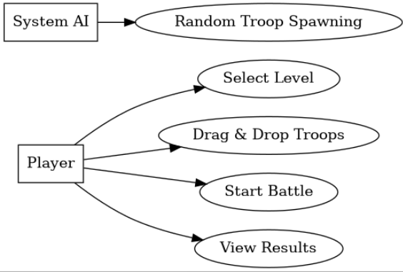

- Use Case Diagram (Multiplayer)
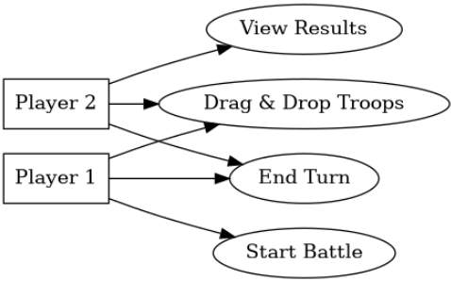

- Architectural Diagram (Single Player)

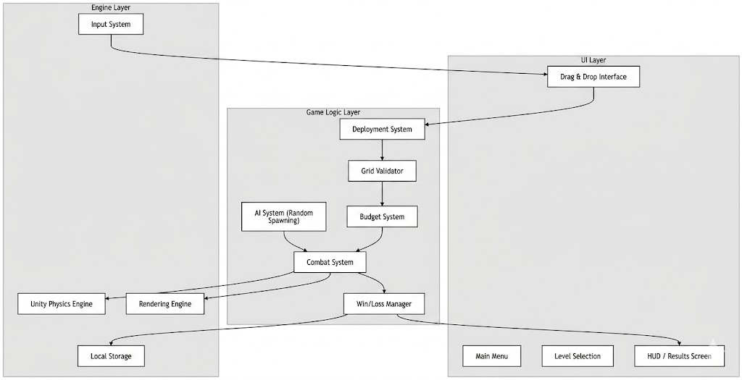

- Architectural Diagram (Multiplayer)

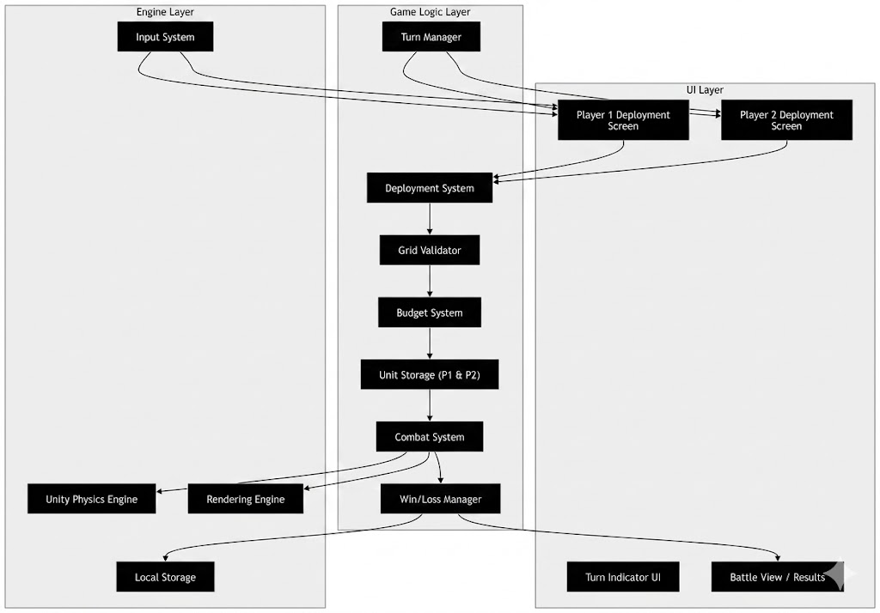

- Activity Diagram (Single Player):
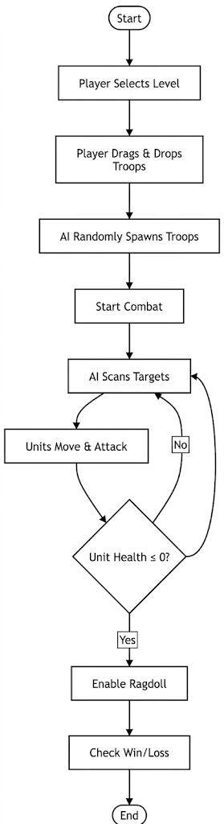
- Activity Diagram (Multiplayer):
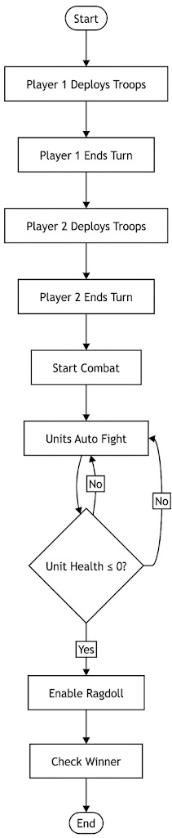
- Class Diagram (Single Player)
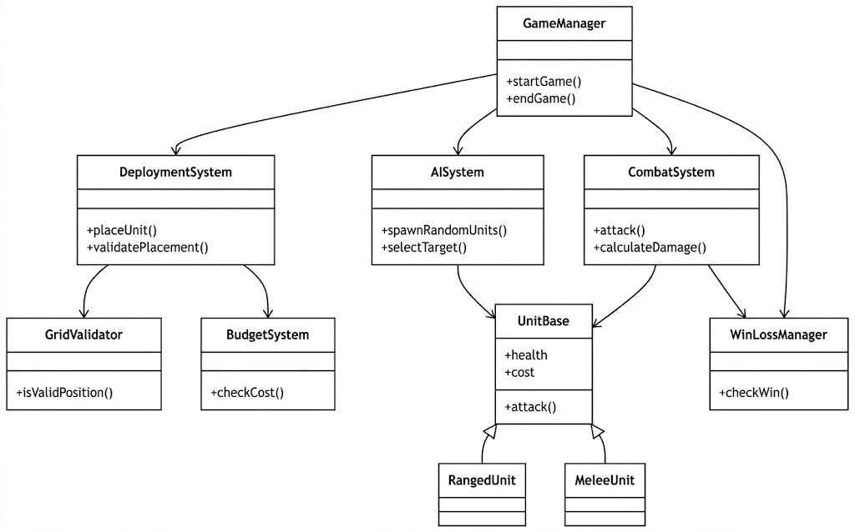

- Class Diagram (Multiplayer)
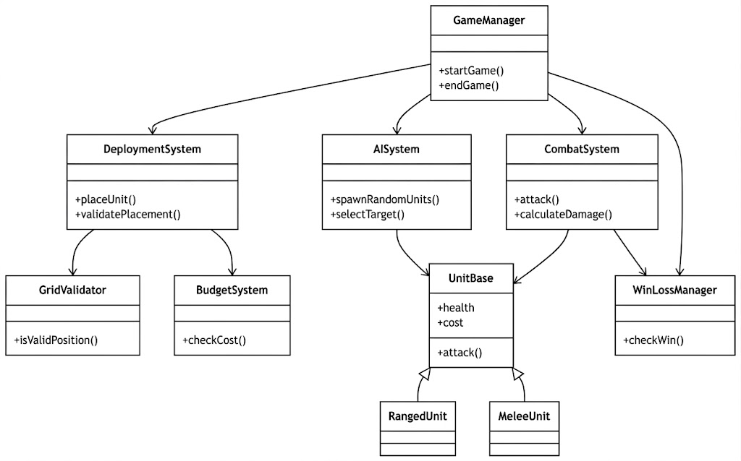

- DFD Diagram (Single Player)

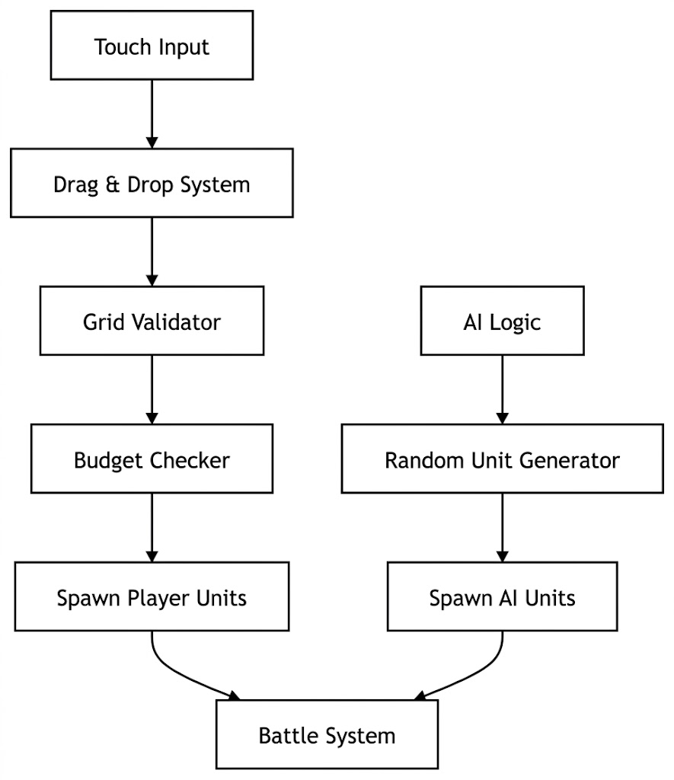

- DFD Diagram (Multiplayer)

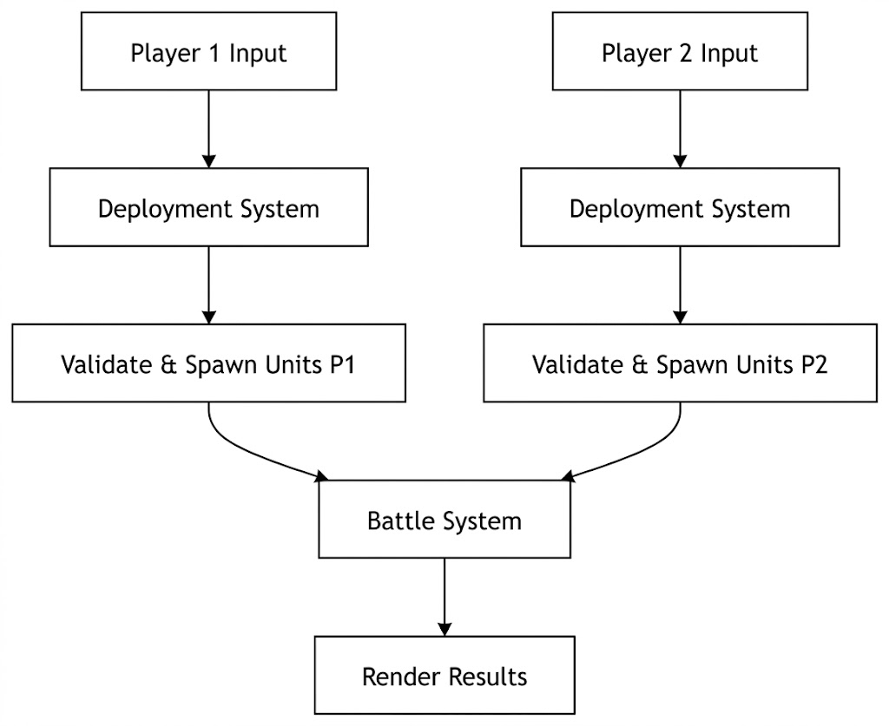

6.3 Mathematical Physics Modeling and Rigid Body Dynamics
One of the key technical pillars of Ragdoll Royale is that it is based on intricate and realistic physics simulations to solve combat. The mathematical model of the autonomous units need to be formally documented in order to justify the architectural choices made regarding the implementation of the Entity-Component-System (ECS).
The Unity PhysX engine is based on the principles of classical Newtonian mechanics. Each unit of the battlefield is not a single, solid object, but a complicated hierarchy of interrelated rigid bodies (the head, torso, upper arms, forearms, thighs and calves). The Second Law of Motion of Newton applies to the translational motion of these individual rigid bodies:
F = m * (d²x/dt²)
In which, F is the net force vector on the rigid body, m is its scalar mass, and d 2 x/dt 2 is the second time-derivative of position (acceleration). In the autonomous combat stage, when a Sci-Fi laser trooper launches an assault on a Stone Age spear warrior, the system determines the exact force vector that the impact produces.
But to convert translational force to real world ragdoll tumbling, rotational dynamics must be computed. The angular impulse that the limb of a unit undergoes when impacting is calculated by the torque:
τ = r × F
The torque is denoted by Tau, the displacement by r and the force by F. In order to avoid the mathematical oddities of the so-called Gimbal Lock when performing such chaotic rotational calculations, the software architecture makes explicit use of Quaternions instead of conventional Euler angles that are used to represent 3D rotations.
Moreover, the architectural complexity is added to by the need to have Joint Constraints. Ragdolls do not just fly apart and the rigid bodies are connected by configurable joints which model biological constraints. The engine has to continuously solve constraint equations, to make sure that a forearm of a unit does not rotate by 360 degrees around an elbow joint. To compute these constraint resolutions on more than 20 units at once, requires enormous matrix multiplications per frame. The mathematical density will require the cache friendly data arrays that have been optimized heavily by the ECS architecture and will keep the arithmetic logic units (ALUs) of the mobile CPU supplied with successive memory blocks, keeping the performance constraint of at least 60 FPS strict.

Chapter 7

IMPLEMENTATION AND TESTING

7.1 Introduction to the Implementation Phase
In this chapter, the author gives a detailed narrative exposition of the particular methods, advanced software tools and advanced programming techniques that were used to transform the theoretical software architecture of the program Ragdoll Royale to a compiled, fully executable. Implementation is the crucial stage in which abstract Unified Modeling Language (UML) diagrams, entity-relationship models, and algorithmic pseudocode are then systematically converted into strict object-oriented C# code in the Unity run-time environment. The key target in this stage was to make sure that the internal software features namely the highly intricate, touch-based tactical deployment as well as the highly volatile autonomous physics simulations were created with the help of controlled libraries and strong structural templates. This method ensured that the suggested software could be tested and constantly measured at the runtime with the original, high standards identified in the SRS thus being fully aligned to the original problem statement.

7.2 Core Functionalities Implementation in Narrative Format
To make the software realize the core functionality, it was necessary to carefully implement a number of highly interdependent subsystems. The Troop Deployment and Budget System is the most significant operational module which was implemented with the heavy use of an event-driven programming paradigm to provide maximum responsiveness of the user interface. In order to obtain the drag-and-drop behavior desired on touchscreens, the development group adopted a continuous mathematical raycasting algorithm. The 2D pixel coordinates of the touch-point of the user on the mobile display are dynamically converted by the system into a 3D vector, which is projected into the virtual world as a ray. This ray only interacts with a predefined physics layer known as the "Legal Zone." When the mathematical intersection point is within this limit, the engine allows a temporary instantiation of the chosen troop prefab.
After the player confirms the layout of the deployment, the game state is switched to the Autonomous Battle Simulation phase. The phase is wholly dependent on the effective implementation of the Unity PhysX engine. A Finite State Machine (FSM) was programmed to each unit to instantiate the autonomous battle logic without overloading the mobile CPU. Instead of running decision trees on each frame, the units are in discrete states. When battle is initialized, units enter a Target Acquisition state, with overlapping mathematical spheres to identify the closest enemy collider in a specified radius. Upon locking an enemy, the state machine switches to an "Engage" protocol, which takes control of the local navigation mesh agent on the unit and gives it the command to move into the 3D environment toward the target. Health integer variables that were monitored locally were used to implement the combat resolution. When the health of a unit goes to zero a critical state interrupt is generated by the system, which overrides the normal animation controller and also liberates a sophisticated rigorous array of rigid body parts and joint constraints. It is this smooth programmatic transition that produces the dynamic mathematically computed ragdoll physics that become the visual identity of the combat system of the software.
Furthermore, the implementation of the multiplayer architectures required precise synchronization protocols. For the offline, pass-and-play local multiplayer, the software state manager was programmed to strictly enforce turn-based alternations, completely disabling camera rendering and input functionality for the inactive player to preserve the integrity of the hidden deployment strategy. Thanks to the fact that both players are on the same device, the physics engine calculates the exact multigrom effect and battle result without any need to expensive network synchronisation or server-side physics validation, satisfying the requirements of multiplayer games.

7.3 Testing Methodologies and System Evaluation
A very rigorous, multi-level testing approach was adopted to guarantee that the end software that would be compiled showed absolute reliability and fulfilled all the predetermined software quality criteria. The testing plan was clearly intended to critically examine the accuracy, performance and scalability of the proposed software in a runtime environment.
The bottom section of the testing process was tiring unit testing. At this stage, the individual classes and separate algorithms in C# were thoroughly mathematically analyzed. To take an example, the mathematical consistency of the algorithms used to compute the Euclidean distance between autonomous agents was checked with known numerical constants to ensure mathematical correctness, and such units would only attack enemy physically violating their assigned attack radius.
After the team successfully completed unit validation, it performed a thorough integration testing. This was the critical phase of a physics-based application, as it tested the complicated hand shake protocols between the user interface layer and the physics engine on which it relies. During the drag-and-drop deployment stage, the testers paid special attention to edge cases, willingly trying to drag units into overlapping geometries, or dragging them to the extreme limits of the legal deployment space. These tests effectively confirmed that the spatial hashing functions and collision detection matrices were symbiotic in nature, and effectively avoided unlawful placements and structural integrity of the application ruleset.
The most important stage of the assessment process was the Performance and Scalability Testing, which was performed on the target middle-end mobile hardware environments (Android 9.0+ and iOS 13+ devices) directly. This stage was a critical performance estimate of the computational load of the Unity PhysX engine at the extreme limits of the project scope. The software was put under extreme loads conditions, namely making render and simulating the use of complex joint constraints and collision calculations of 20 or more concurrent ragdoll units. Through the Unity Profiler, the development team was able to carefully track CPU thread assignment, and GPU rendering time, and thermal battery decay. The assessmentes conclusively demonstrated the fact that the adopted object-pooling memory management methods and layer-based collision culling algorithms were very successful. The software proposed was kept in a highly stable running mode, and it was always capable of reaching the necessary benchmark of 60 or more frames per second, and all instantiations of levels loaded within the necessary 5 or less seconds limit.

7.4 Screen-by-Screen Interface Implementation Narrative
The User Interface (UI) implementation was done with a firm commitment to the mobile usability principles, so that the non-expert users would be able to navigate through the intricate layers of the application tactic without any issue. The implementation of the main visual interfaces as a narrative is described in this section.
7.4.1 The Main Hub and Navigation Architecture
The Main Menu is the heart of circulation of the application. Introduced with the help of the Unity Canvas UI system, the screen is structured in such a way that visual clarity is given priority. Background rendering is characterized by dynamically lit slow-panning camera view of a deserted battlefield, which creates an instant aesthetic tone of the game. The major touchable objects are oversized and easily tapped bounding boxes that are touch-friendly. The implementation logic will determine that these buttons use asynchronous scene loading protocols. When a player chooses the Campaign option, the system does not block the main thread but rather, it starts a background coroutine to load the intensive 3D resources of the Level Select Screen into memory without disrupting a smooth and responsive UI animation on the front end.
7.4.2 The Tactical Deployment Interface
The deployment phase of the project involving the implementation of the Gameplay Screen is the most complex UI engineering. There are two basic layers of interaction in the screen. The 3D computer-generated environment is provided by the world-space layer and the tactical information is given by the screen-space overlay. Anchored to the bottom of the screen is the Scrollable Troop Roster. This feature was achieved by way of a dynamic object-pooling system; instead of creating a new UI button each time the player is presented with a single unit type on any one of the Military, Modern, Sci-Fi, and Mythic factions, the system uses a fixed number of UI containers, and injects the appropriate sprite graphics and integer cost data accordingly, depending on the position of the scroll that the player is currently standing in.
Placed at the upper-left corner of the interface is the Dynamic Budget Display. This text element will be implemented through the Observer design pattern. The core BudgetManager class has an event delegate broadcast on which the text component subscribes. When a fiscal change is made, either by deduction when a unit is placed, or by refund when a unit is removed, it is fired, and the UI text is immediately updated without the need to run a computationally taxing Update() loop checking every frame. Lastly, there is a prominent Initiate Battle confirmation element that is pinned to the right quadrant, which intentionally needs a separate, second touch confirmation to set the deployment grid and into the autonomous simulation state of the software.

Chapter 8

RESULTS AND DISCUSSION

8.1 Comprehensive Evaluation of the Solution
At the end of the intensive software development lifecycle of the "Ragdoll Royale" project, the final product is an extremely streamlined and fully operational mobile strategy application that tackles the initial problem statement in a comprehensive manner. The chapter is a very analytical analysis of the ultimate solution, which summarizes the information obtained during the long period of testing the system and the implications of the results in relation to the initial project specifications. The overall outcome of the project is the effective implementation of a powerful, physics-based tactical simulator that can be executed without issue within the computational limitations of the current mobile platforms, free of any predatory monetization schemes.

8.2 Operational Results and Strategic Gameplay Mechanics
The performance indicators of the finished software show beyond reasonable doubt that the complex emergent gameplay could be successfully implemented in a mobile environment. Throughout the system testing, the autonomous battle simulation subsystem was very reliable. After a player is done setting up his strategic deployment, the system perfectly hands the execution to the programmed Artificial Intelligence. The testing cases that encompassed all possible use cases and deployment variations ensured that the units were independent in identifying enemies, finding paths in the most efficient way possible within the computer-generated environment, and fighting in a model-independent way.
More importantly, the ragdoll physics interactions thus produced essentially addressed the original issue of statical, deterministic combat systems. Since the fighting is determined mathematically through the collisions of rigid bodies and the velocity vectors instead of being determined by pre-programmed animations, the result of each individual battle, both visual and strategic, is completely unique. This new behavior compels the player to examine the post-battle data, namely the ratings of the budget efficiency and the number of units lost, and progressively improve the strategy in the next tries. The game manages to utilize these analytics and correctly enter the ultimate win or loss state of just the autonomous survival of the respective factions. (Insert Figure 8.1: A graphical display of the Post-Battle Results Interface, which breaks down an analysis of a completed simulation (in more detail).

8.3 Validation of Safety, Security, and Business Rules
One of the greatest aims of this project was to design a software environment that fully eliminated the unfriendly, hostile traditions that prevailed in the existing mobile market. The final build is reviewed to ensure complete compliance with all required safety, security and ethical business guidelines. The development team was able to complete the whole application without integrating one third party advertising Software Development Kit (SDK). As a result, the game creates a fully continuous, family-friendly, aesthetic that lacks any objectionable or misleading third-party material. The ability to generate revenue was only limited to secure and localized in-game purchases. In addition, the application architecture was audited to the utmost security level to ensure that it does not gather any personal telemetric data at all, and that all the campaign progress, unlocked factions, and graphical settings are serialized and stored in the secure file system of the local device strictly.

8.4 Discussion of Technical Achievements
The technological success of this project is of great importance in the context of mobile games creation. Traditionally, the localized gravity, angular drag and complex joint intersections of dozens of ragdoll models would be processed, and would cause catastrophic thermal throttling of middle-end mobile hardware, along with huge frame-rate loss. According to the system testing data, it is obvious that the choice to decouple the data architecture with the help of an Entity-Component-System (ECS) paradigm in which the physics calculations are performed was the right architectural direction. The software can be scaled very simply to the necessary 20+ units per battle, making the physics simulations unruly smooth at a solid 60 FPS.

Chapter 9

CONCLUSION AND FUTURE WORK

9.1 Summary of Project Achievements and Conclusion
The initial conception of this Final Year Project was influenced by a very tangible, visible issue in the mobile interactive entertainment industry: the ubiquitous flooding of the strategy genre with games that were largely based on predatory monetization and gameplay that was mathematically uninteresting and inactive. Ragdoll Royale was developed and then designed as an ultimate counter-measure to these industry-wide shortcomings. This report has described in detail the process of meeting this problem statement, starting with the intensive documentation of the user requirements going through to the complicated architectural design of a powerful physics engine of the Unity runtime environment.
The proposed solution successfully completely addresses the core problems identified. The application ensures a very safe, all-kid-friendly environment by methodically eliminating all external advertising networks, and relying solely on an ethical in-game purchase model. Gameplay-wise, with the combination of self-directed Artificial Intelligence via a powerful rigid-body physics engine, there is always non-deterministic combat. The need to play a game with a limited tactical budget and to strategically position varied factions, such as Military Snipers, Mythic Dragons, etc. compels a high level of cognitive processing and learning through observation. The tiring tests conducted in the testing stage give empirical data that the solution is indeed solving the problem; the application is able to execute mind boggling, multi-threaded ragdoll calculations on more than 20 units at a time with remarkable consistency, and within exact performance standards of at least 60 frames per second on the targeted mid-range mobile hardware without crashing or decaying memory. Finally, Ragdoll Royale is an extremely refined, academically sound work of optimal mobile software implementation and ethical game development.

9.2 Recommendations and Future Work
Although the existing, packaged version of Ragdoll Royale is well within the minimum functional and non-functional specifications as described in the original specification, the scalability of its modular design offers an outstanding basis of development in the future. In regards to the analysis of the existing software build, the following instructions can be strongly advised as a part of the further work of the project:
- Machine Learning AI Implementation: The autonomous units are currently using a deterministic Finite State Machine to find paths and target acquisition. The next step in work might be the implementation of deep reinforcement learning models, so the AI will naturally have to learn the deployment strategy of the players, and adjust the defensive formations in a more dynamic way, which will bring the single-player difficulty curve up exponentially.

REFERENCES
[1] IEEE Computer Society, "IEEE Recommended Practice for Software Requirements Specifications," IEEE Std 830-1998, 1998.
[2] Unity Technologies, "Unity User Manual (2022.3 LTS) - Physics and Rigidbodies," Unity Documentation, 2023.
[3] J. Gregory, Game Engine Architecture, 3rd ed. Boca Raton, FL: CRC Press, 2018.
[4] I. Millington, Game Physics Engine Development: How to Build a Robust Commercial-Grade Physics Engine for your Game, 2nd ed. San Francisco, CA: Morgan Kaufmann, 2010.
[5] I. Millington and J. Funge, Artificial Intelligence for Games, 2nd ed. Boca Raton, FL: CRC Press, 2009. (Use this to back up your Finite State Machine and autonomous pathfinding logic).
[6] E. Lengyel, Mathematics for 3D Game Programming and Computer Graphics, 3rd ed. Boston, MA: Cengage Learning, 2012. (Essential for citing the math behind your raycasting and spatial validation algorithms).
[7] Unity Technologies, "Optimize your mobile game performance: Tips on profiling, memory, and code architecture," Unity Best Practices Documentation, 2023. (Great for justifying your 60 FPS mobile optimization and Object Pooling methods).
[8] R. Nystrom, Game Programming Patterns. Genever Benning, 2014. (Use this to validate your use of the Entity-Component-System (ECS), State design patterns, and Object Pooling for memory management).

